**Team name: Minimal Hotel.**

**Project Links:** [**https://github.com/iuthub/design-project-minimal_hotel**](https://github.com/iuthub/design-project-minimal_hotel)

[**http://hotelminimal.000webhostapp.com**](http://hotelminimal.000webhostapp.com)

**Members:**

**Bektemirov Ilyos U1710110**

**Azamjonov Islombek U1710149**

**Bakhodirov Oybek U1710065**

**Pardayev Karim U1710054**

**Turgunov Aziz U1710177**

**Abubakr ABDULLAEV U1710236**

Project name: **Minimal Hotel(hotel management)**

Used languages, technologies, frameworks:

HTML5, CSS3, Javascript, JQuery, Php, Bootstrap.

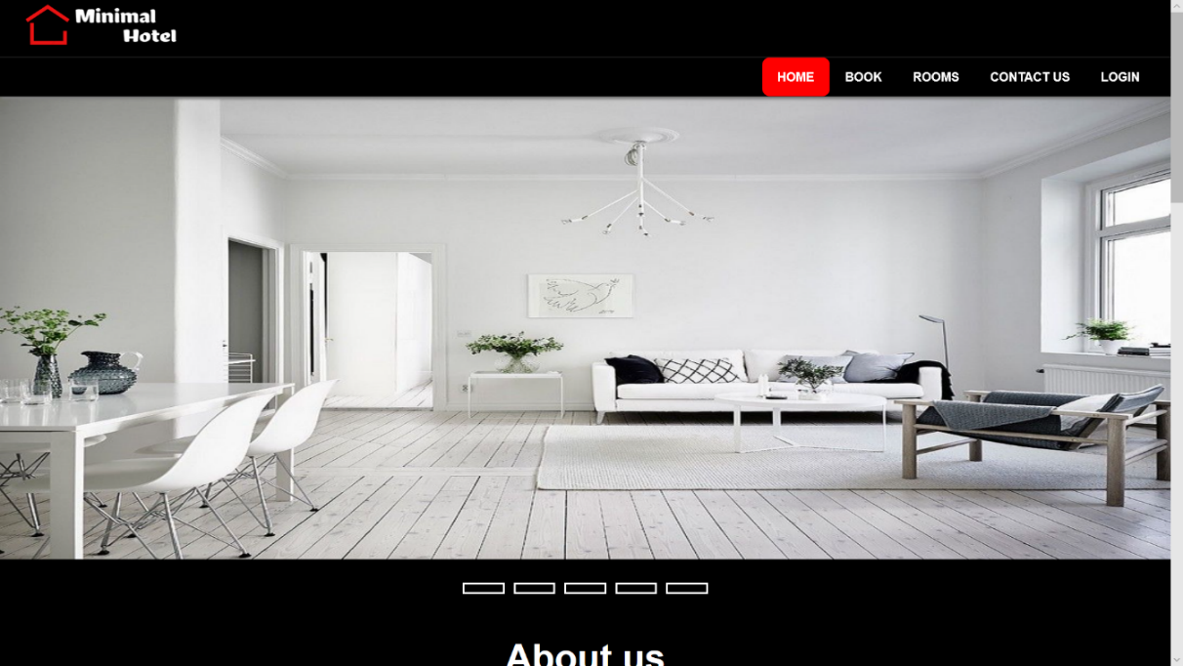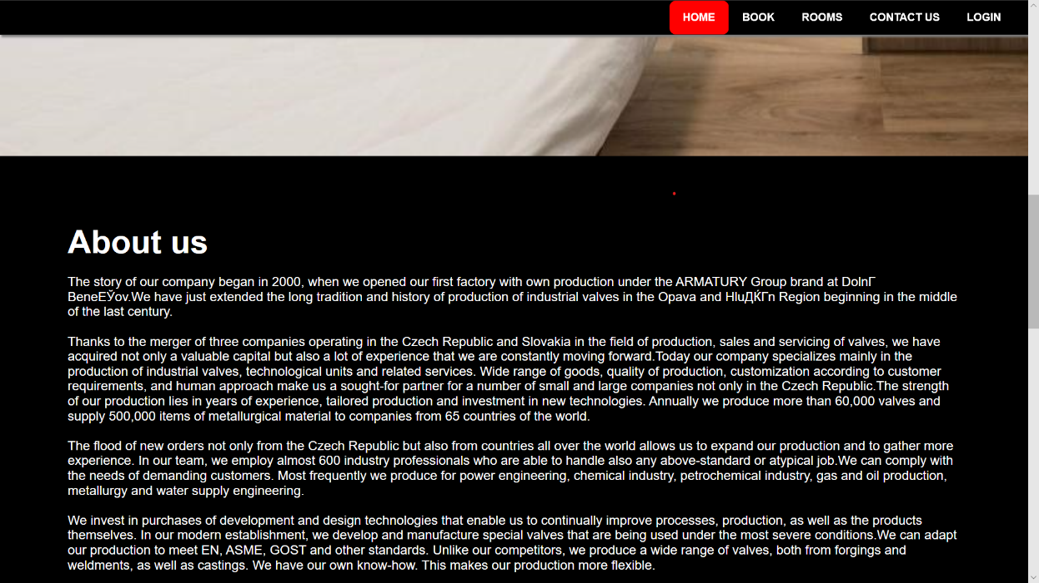FRONTEND:

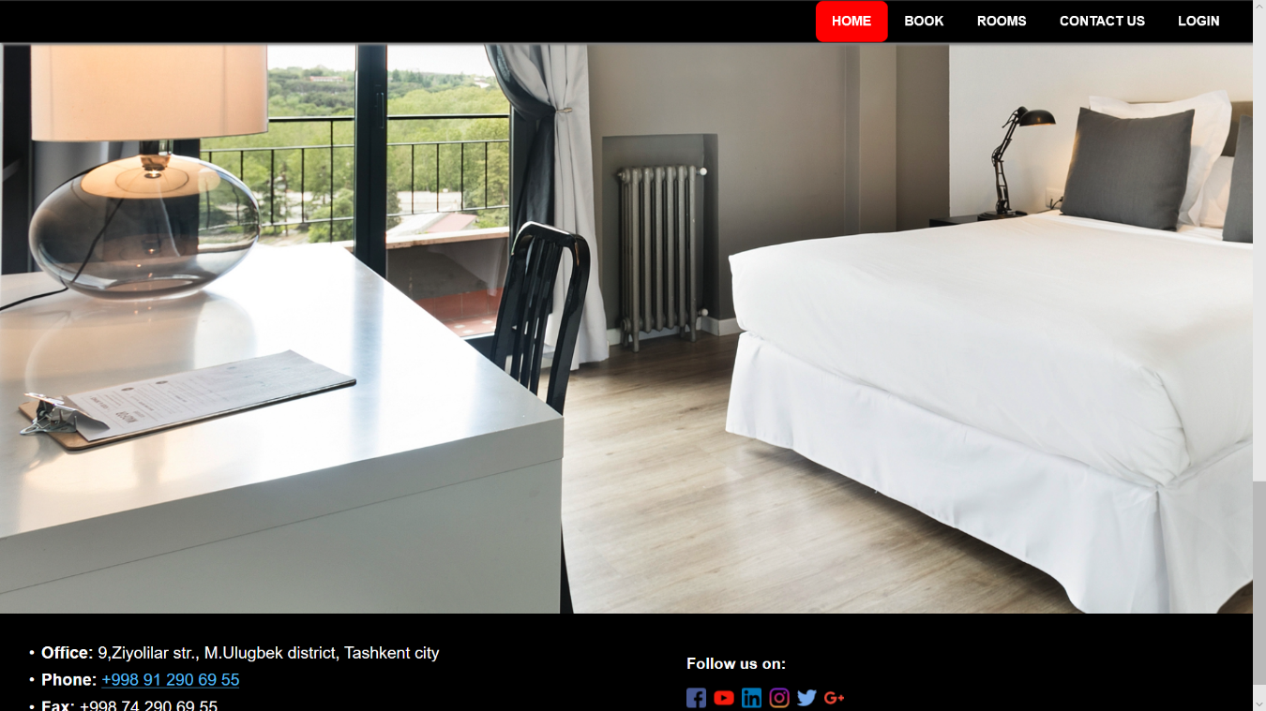On the Home page there are some photos of the hotel , “ About Us “information and some contact information on the bottom . And the user can to swipe the gallery photos of the “Hotel” through java script slider -- multislider.js.

On the bottom of each page there is contact information and links to social webs.

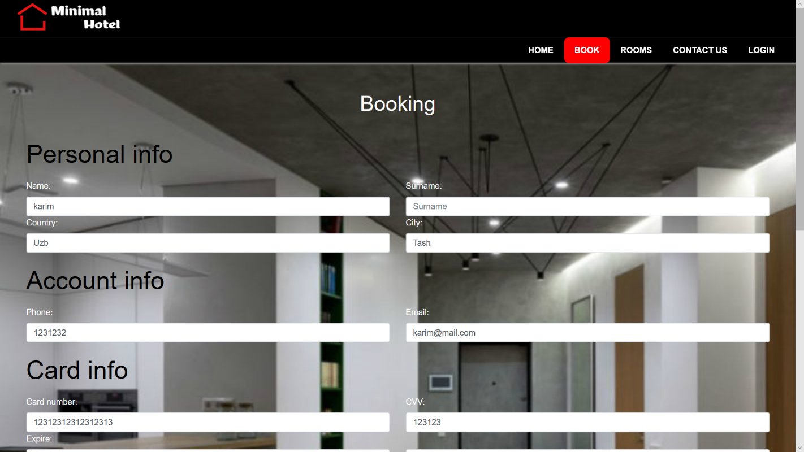On the BOOK page you can see registration menu for further booking. Which implements In the booking system here used both front end and backend validation. Front end validation done used Javascript, regex : email, card number, phone numbers and names

Which the error condition the border of a text panel gets colored red instead of blue.

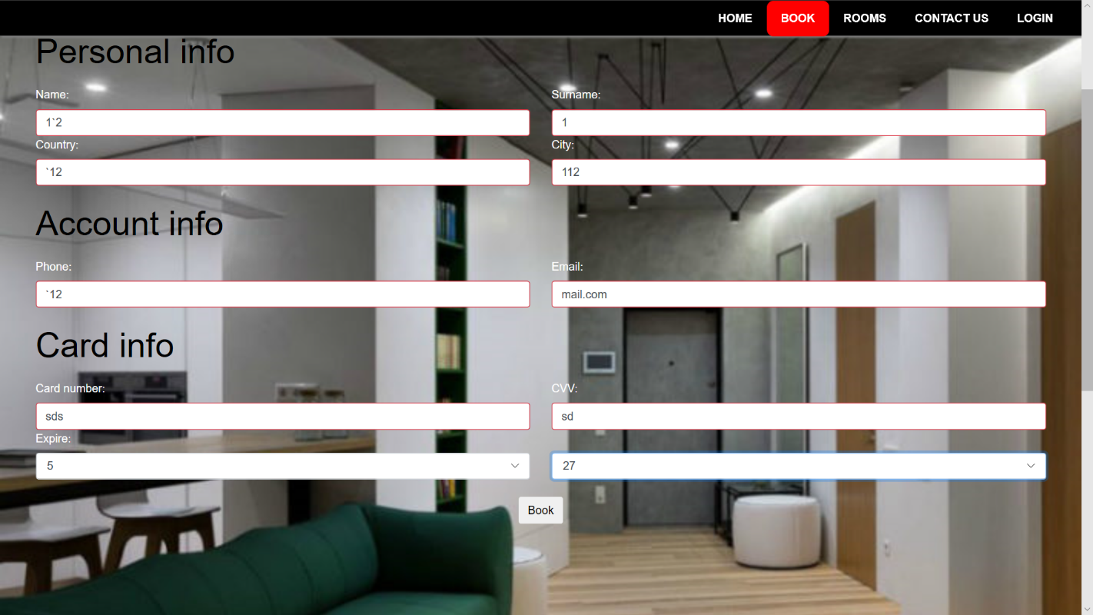

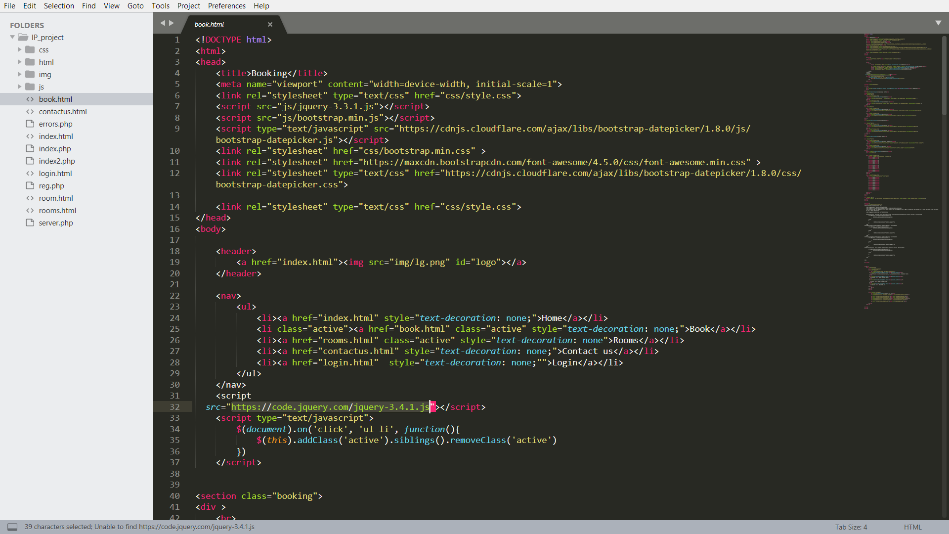And we impleented some Jquery UI feature.

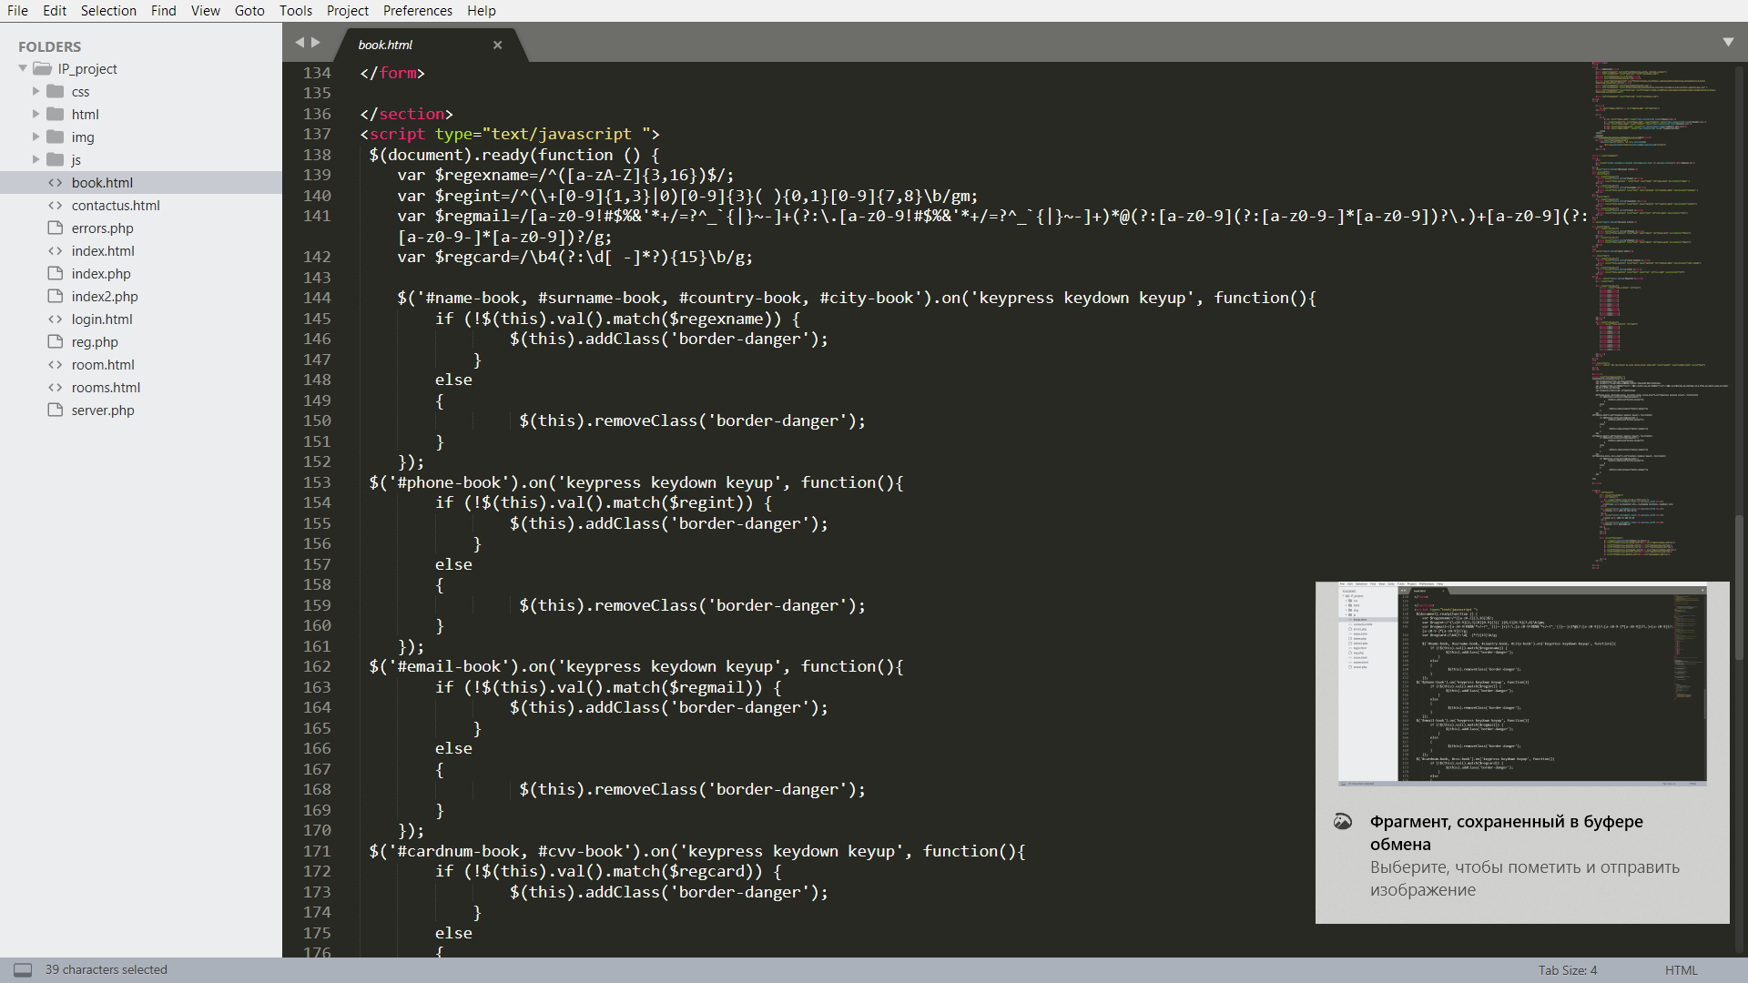

Here is the catalog of rooms

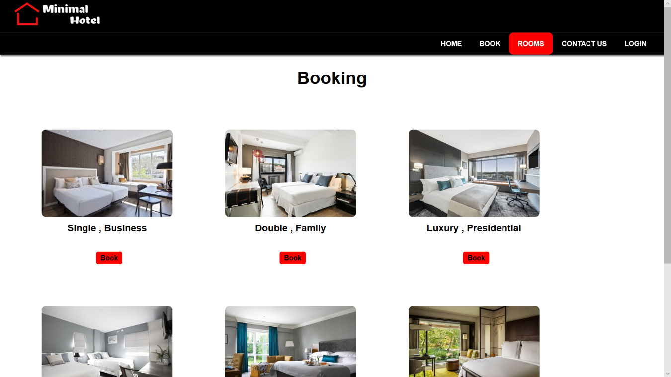

Again Jquery and google map api .

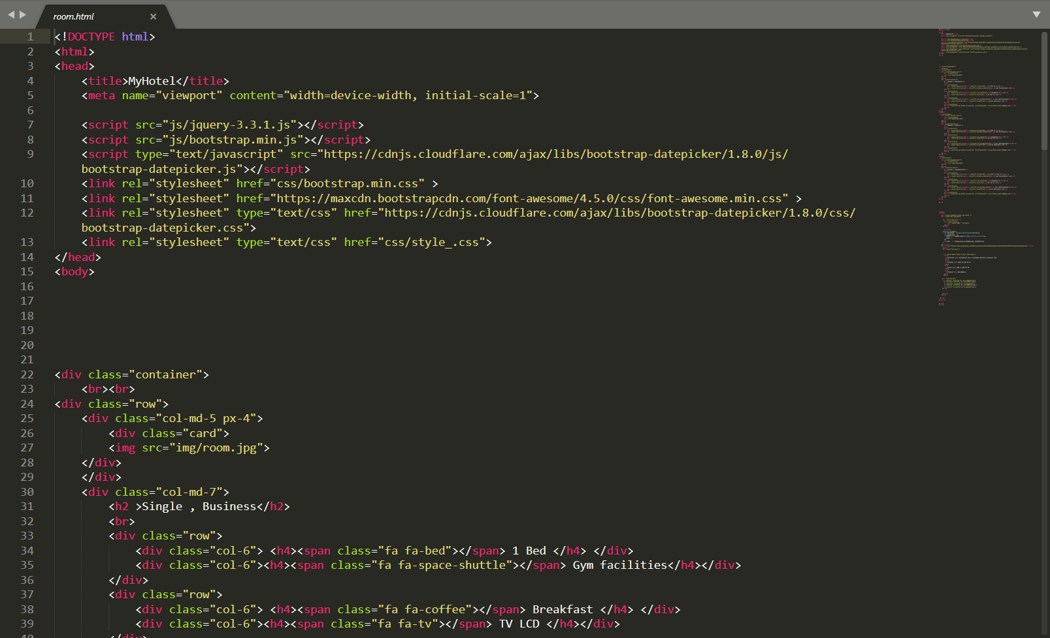

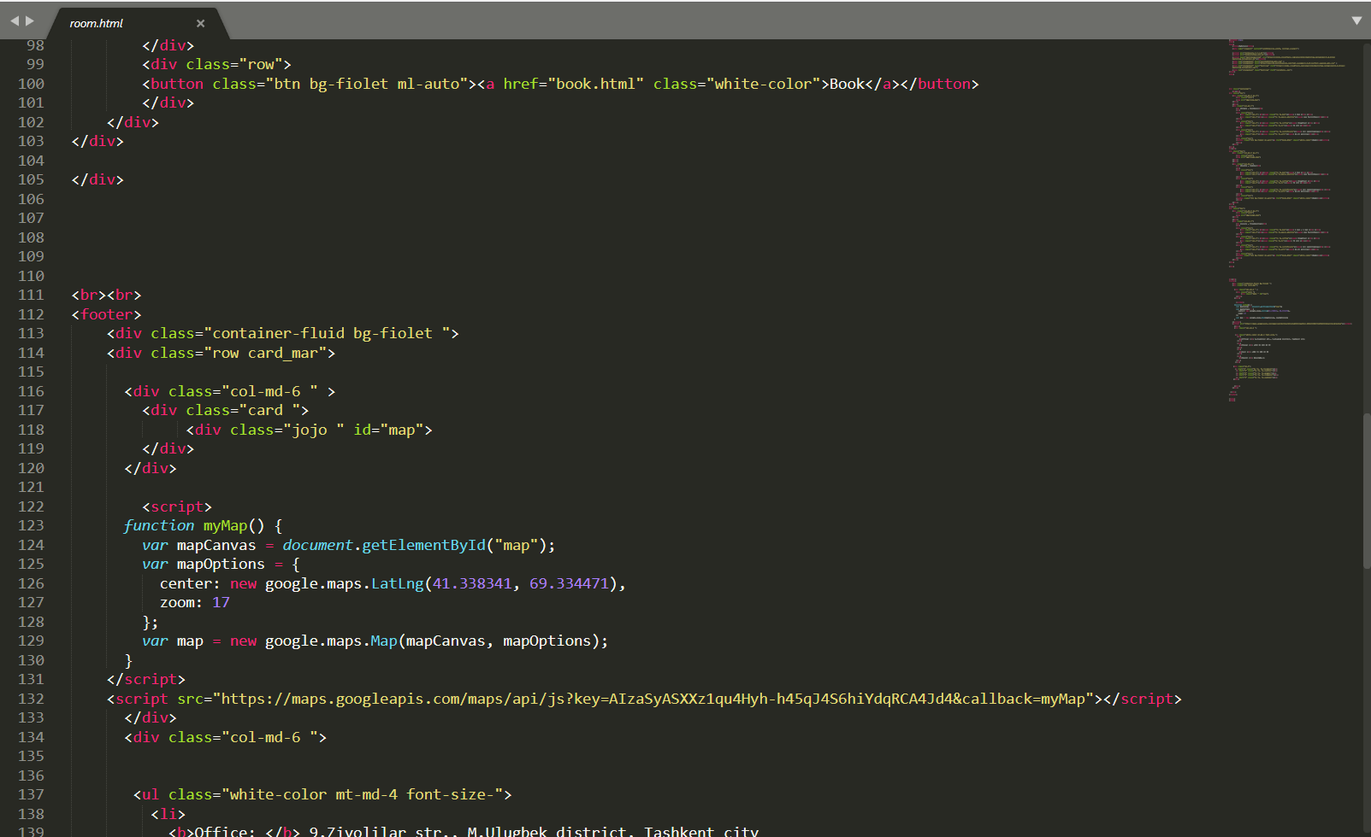

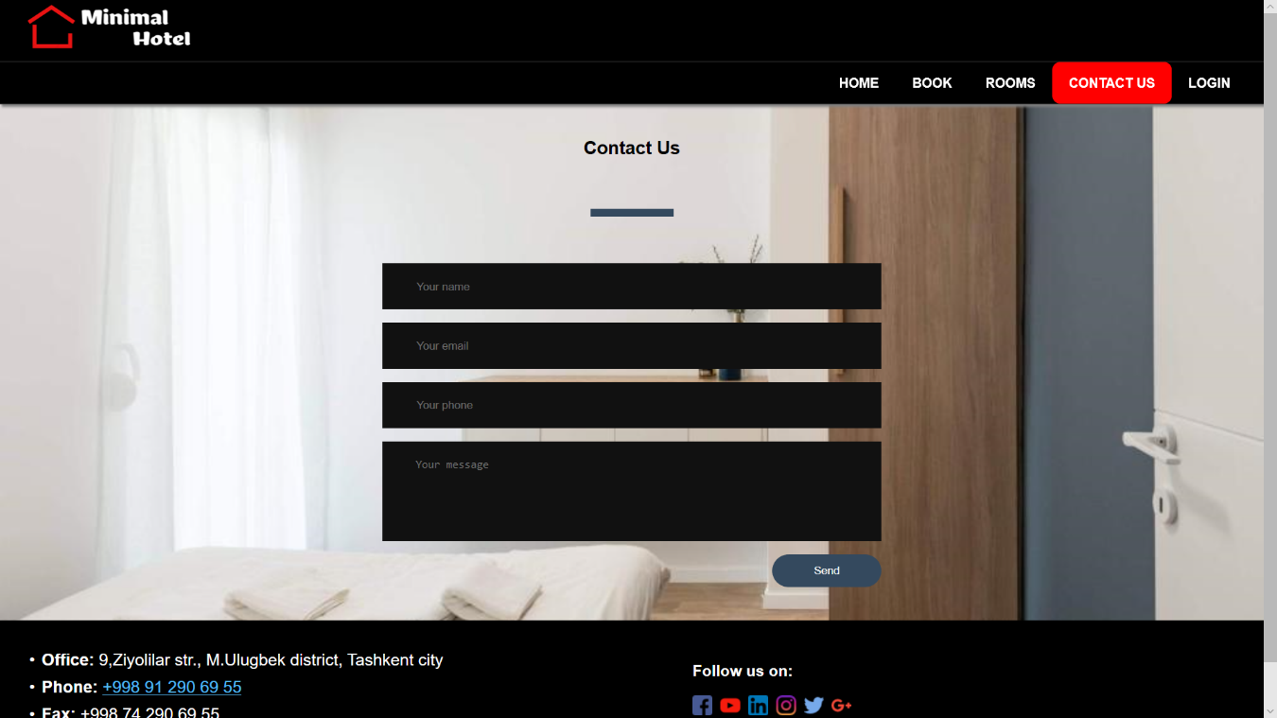On contact us information jquery bootstra.

And finally LOGIN page.

Again Jquery Ui and basic php and js and bootstrap cards.

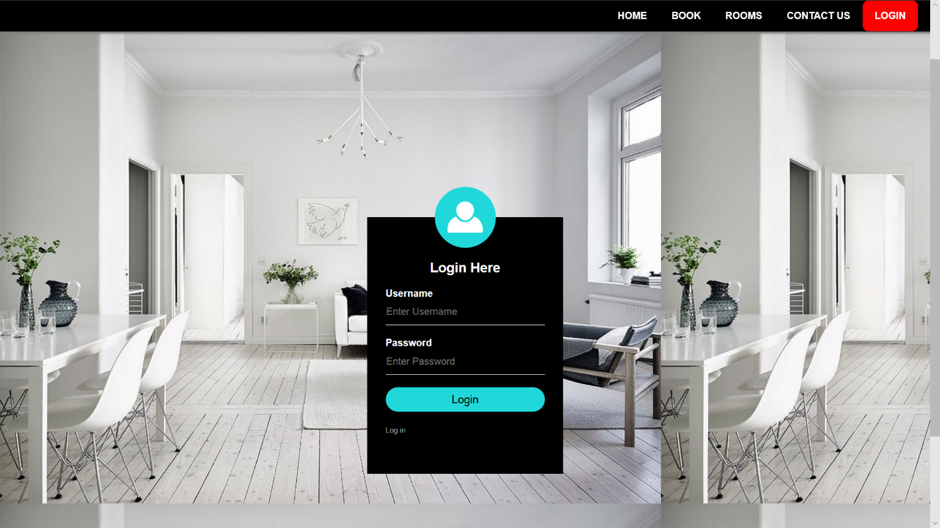

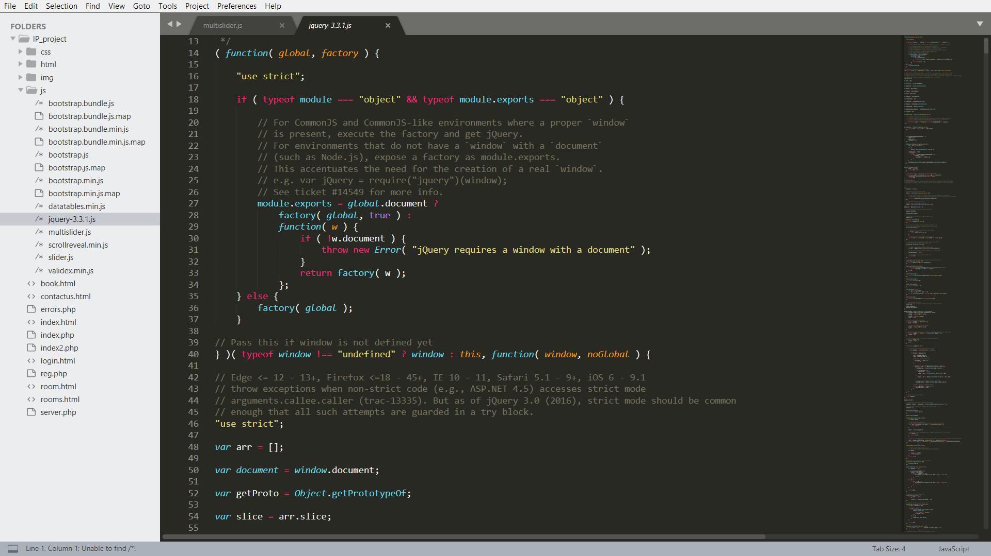

The Jqyery file.

BACKEND:

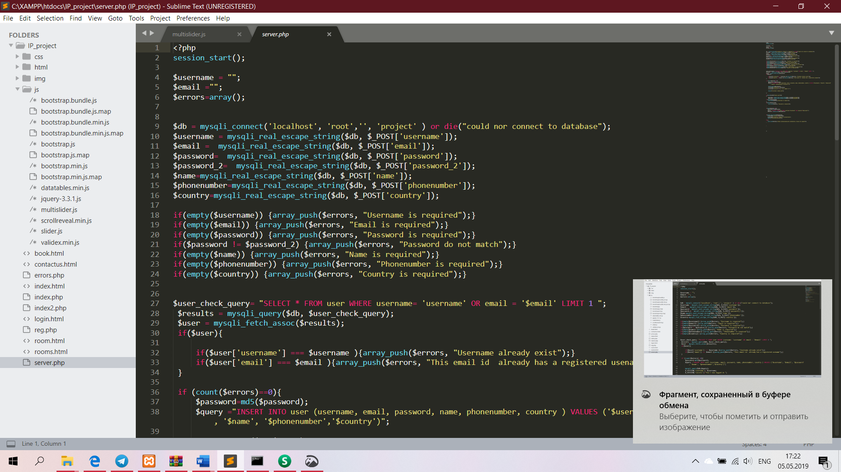

The Serever.php with MySQL database implementation.

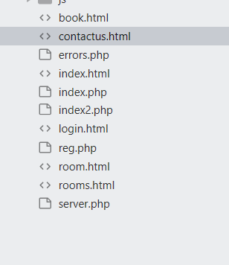

Mistakenly we made project not using GitHub at first we Since we just divided amongst the team . So we didn’t took in to account that the contributions in GitHub plays a role to evaluate the project.

**Bektemirov Ilyos U1710110 Php Html CSS regex, Backend. Login page, Home.**

**Azamjonov Islombek U1710149 Php Html CSS Js bootstrap. Login page, Home. Rooms.**

**Bakhodirov Oybek U1710065 Php Html CSS Js Jquery . Booking registration Home**

**Pardayev Karim U1710054 Php Html CSS JS Backend Report. Login page, Contact us .**

**Turgunov Aziz U1710177 Mostly back end and MySQL db. Contact us, Booking, Login.**

**Abubakr ABDULLAEV U1710236 Php Html CSS as well as JS. Home page, Rooms. Contact us.**